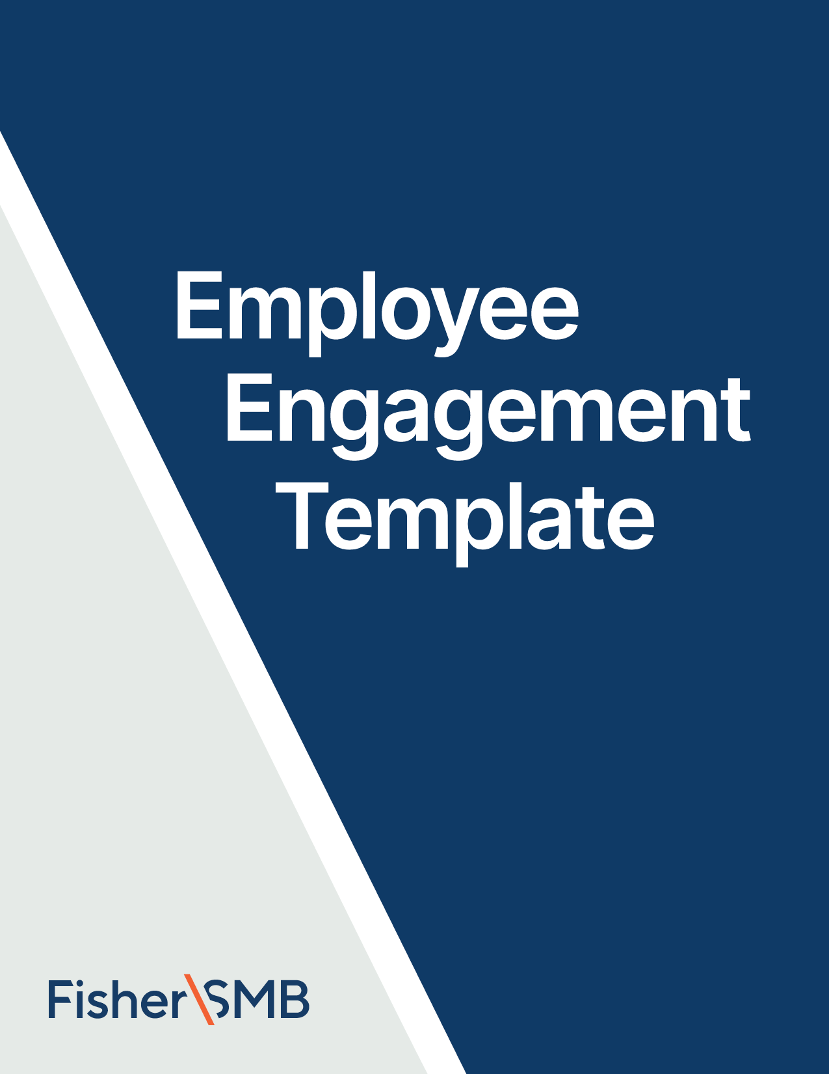



Email Template for September

Theme: National 401(k) Day

Fill in the [highlighted parts]

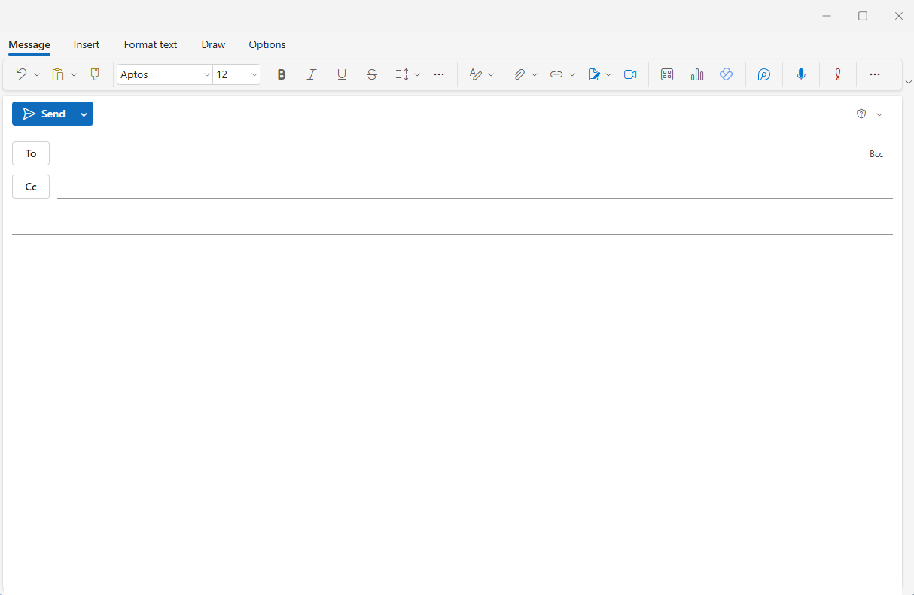

[Employees]

**Subject:** Celebrate National 401(k) Day

Hi [Name],

Happy National 401(k) Day! Your 401(k) is one of the most powerful tools you have to build a comfortable retirement, but it all starts with you taking an active role. This is the perfect time to focus on your financial future and make sure you’re on the right track. Your retirement planning is in your hands, and we’re here to help you make the most of it.

[**Watch this 2-minute video**](https://fishersmb.com/lp/4-ways-to-control-your-retirement-planning-ee/) called *4 Ways You Control Your Retirement Planning* and learn ways to make the most of your 401(k). Take these simple, actionable steps to maximize your savings and help ensure a comfortable retirement.

Taking just a few moments now can set you on the path to achieving the comfortable retirement you envision.

All the best,

[Your Name]

[Signature/Contact]

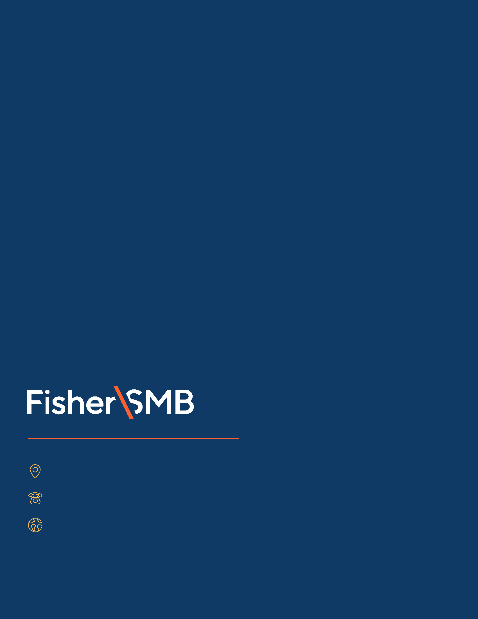

6404 International Pkwy, Ste 1100, Plano, Texas 75093

844-238-1247

www.fishersmb.com

Investing in securities involves the risk of loss. Intended for use by employers considering or sponsoring retirement plans; not for personal use by plan participants. Fisher Retirement Solutions®, Fisher\SMBTM, FisherSMBTM, and all related logos and designs are trademarks of Fisher Retirement Solutions, LLC, which is not connected to Fisher Investments.

©2025 Fisher Retirement Solutions. All rights reserved. K012506MC June 2025