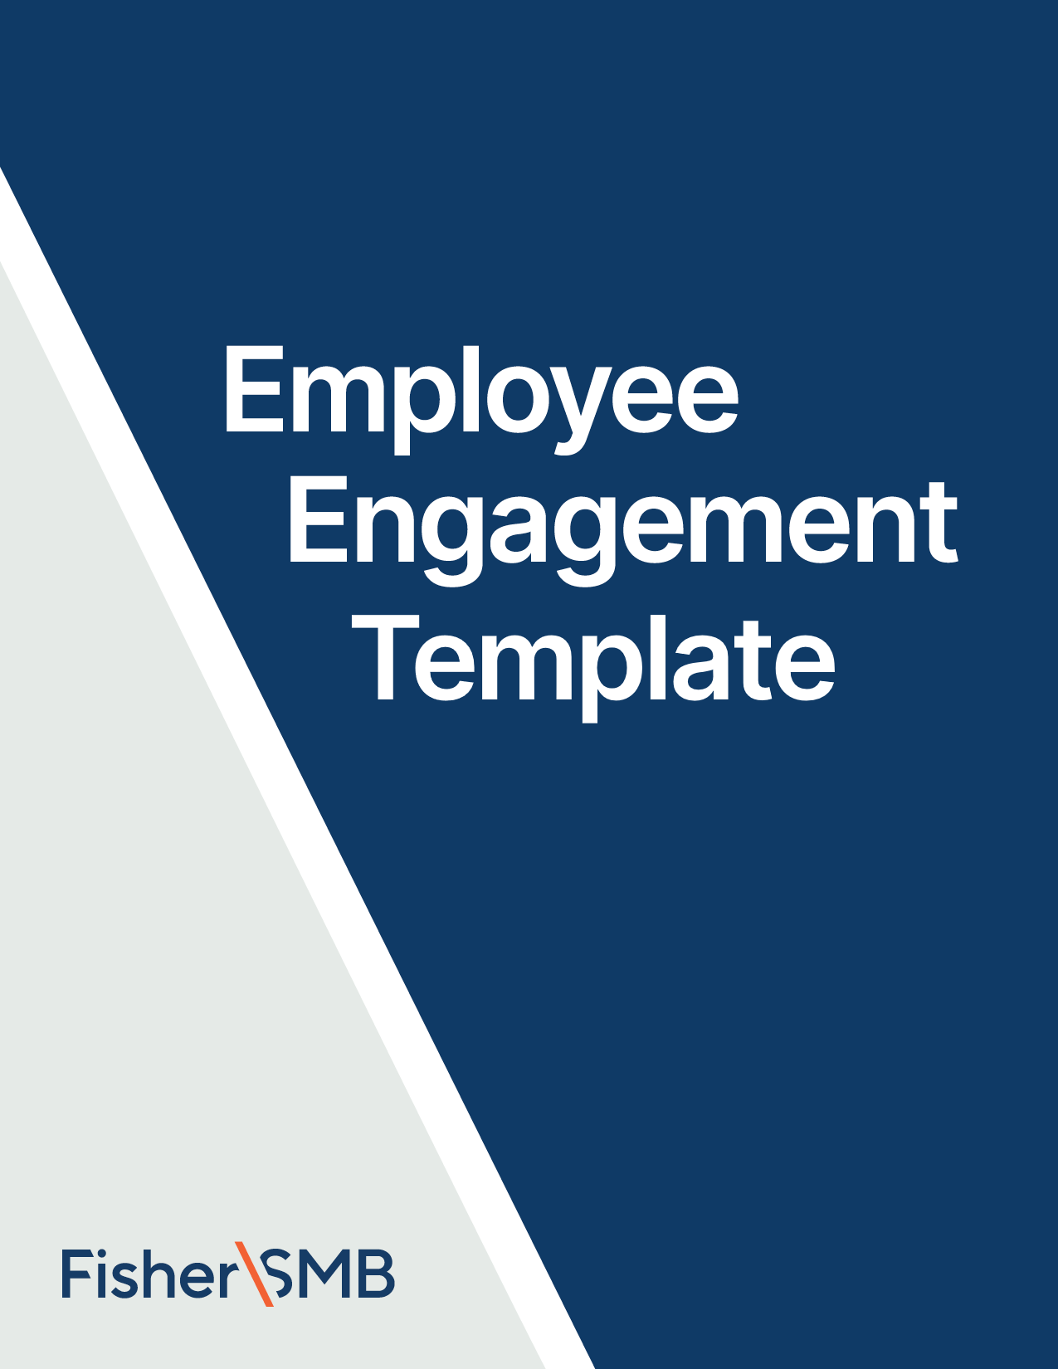



Email Template for January

Theme: Setting Retirement Goals

Fill in the [highlighted parts]

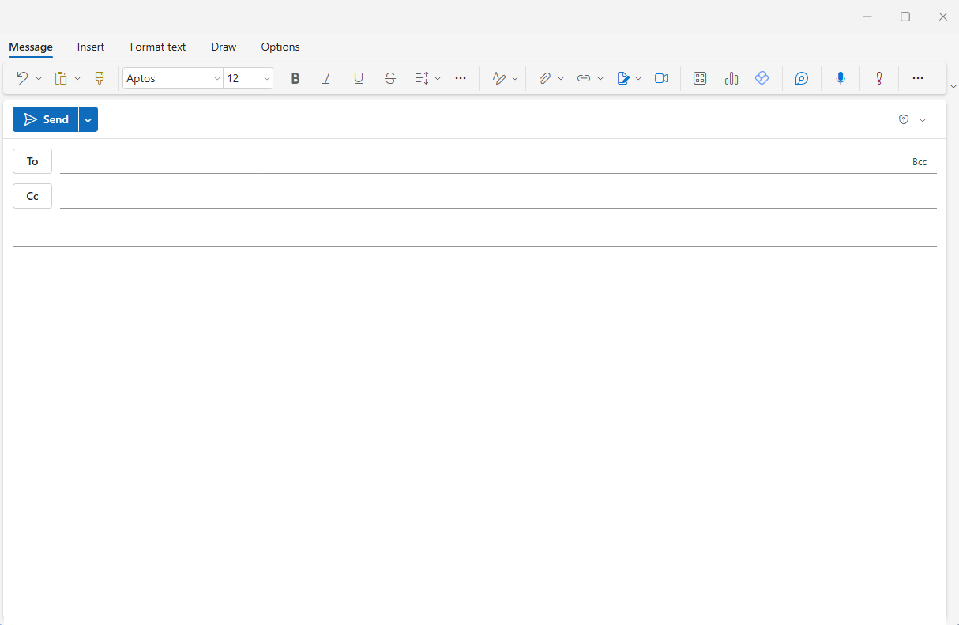

[Employees]

**Subject:** 4 steps to setting your retirement goals

Hi [Name],

With the new year comes a great time to set financial goals for retirement. It only takes a few minutes but can make a huge difference in the quality of your life in retirement.

You can set your goals in just a few steps.

* **Step 1:** Decide your retirement age and calculate the number of years until you reach it.
* **Step 2:** Estimate your monthly living expenses in retirement. Don’t forget to consider that health care expenses are likely to go up as you age.
* **Step 3:** Check on your current savings and estimate how many years of living expenses you already have.
* **Step 4:** Set a savings target and an action plan for how to get there. Can you contribute more from each paycheck to bridge the gap? [**Click here and use this** **retirement calculator**](https://www.fishersmb.com/retirement-calculator/)to help you see what adjustments you may need to make.

Step four is particularly important, especially if you’re young. By setting a target, you’re likely to save more, and the more you save now, the more time your money has to grow.

**Questions?**

If you have questions about your plan and how to make adjustments based on your goals, contact [Name] at [Contact info] for more information.

All the best,

[Your Name]

[Signature/Contact]



Investing in securities involves the risk of loss. Intended for use by employers considering or sponsoring retirement plans; not for personal use by plan participants. Fisher Retirement Solutions®, Fisher\SMBTM, FisherSMBTM, and all related logos and designs are trademarks of Fisher Retirement Solutions, LLC, which is not connected to Fisher Investments.

©2025 Fisher Retirement Solutions. All rights reserved. K012506MC June 2025

6404 International Pkwy, Ste 1100, Plano, Texas 75093

844-238-1247

www.fishersmb.com