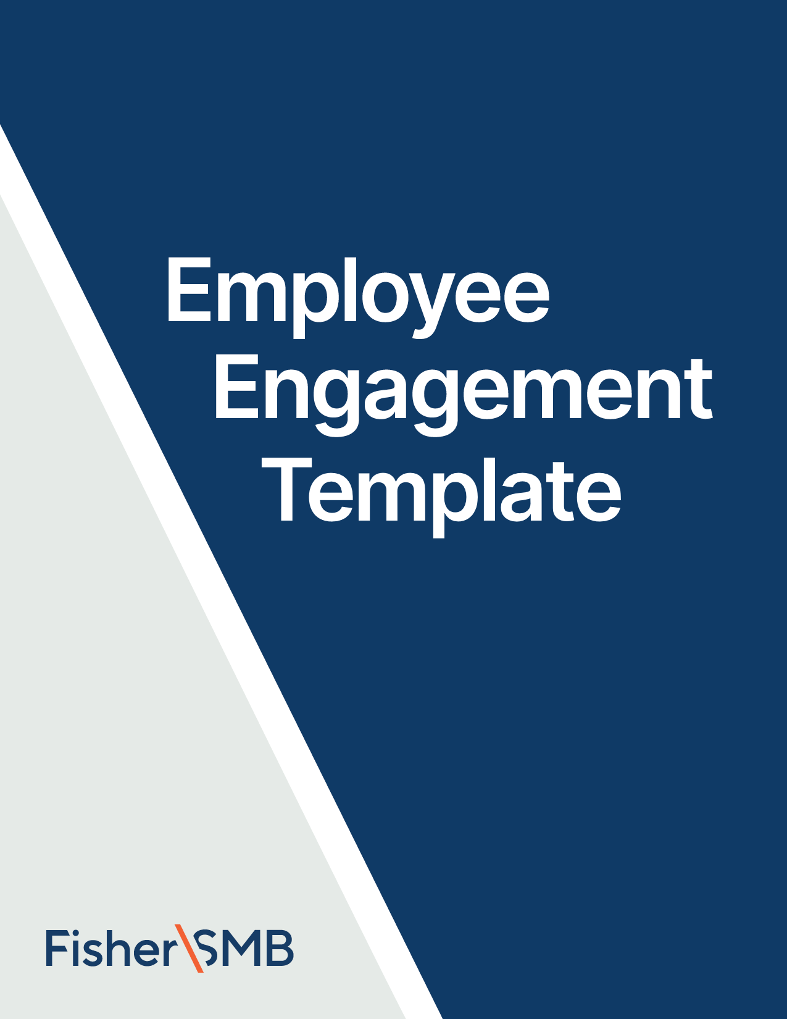



Email Template for February

Theme: February Feedback (Employee Survey)

Fill in the [highlighted parts]

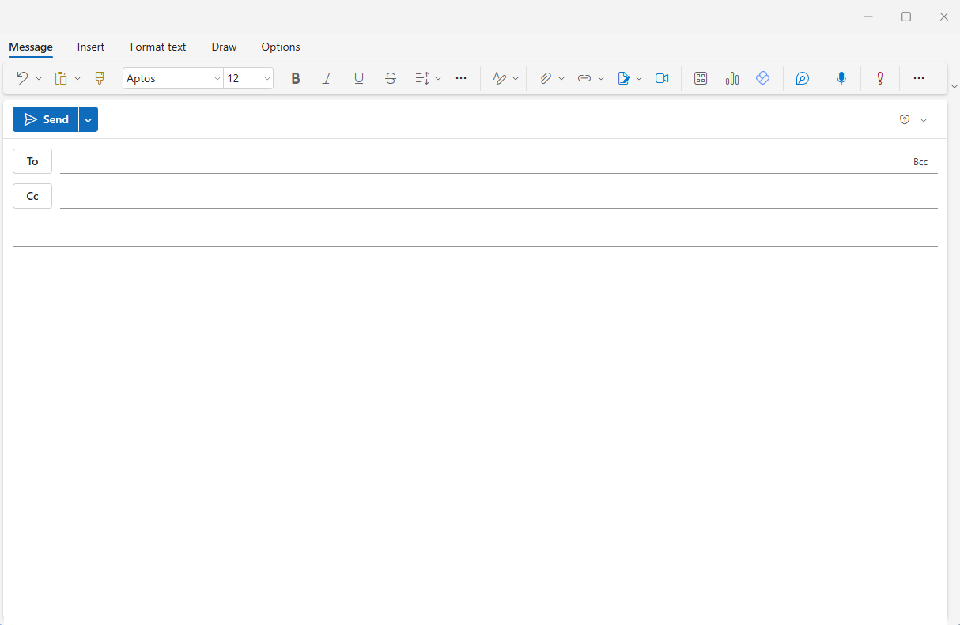

[Employees]

**Subject:** We want your feedback on our retirement benefit

Hi [Name],

Our company’s retirement plan is more than a box to check. Your financial wellness is important to us—now and even after your working days are done.

Take this 3-minute survey to help us understand your experience with our retirement plan and to give feedback that can make the plan better. **The survey is attached.** Please complete and return it to [Contact Name & Email] by [Date].

Thank you for your help! It really can make a difference.

All the best,

[Your Name]

[Signature/Contact]

[**Note to Employer**: For the best experience for your employees, please [**click here**](https://www.fishersmb.com/employee_survey_february/) to download the survey and then attach it to this email.]



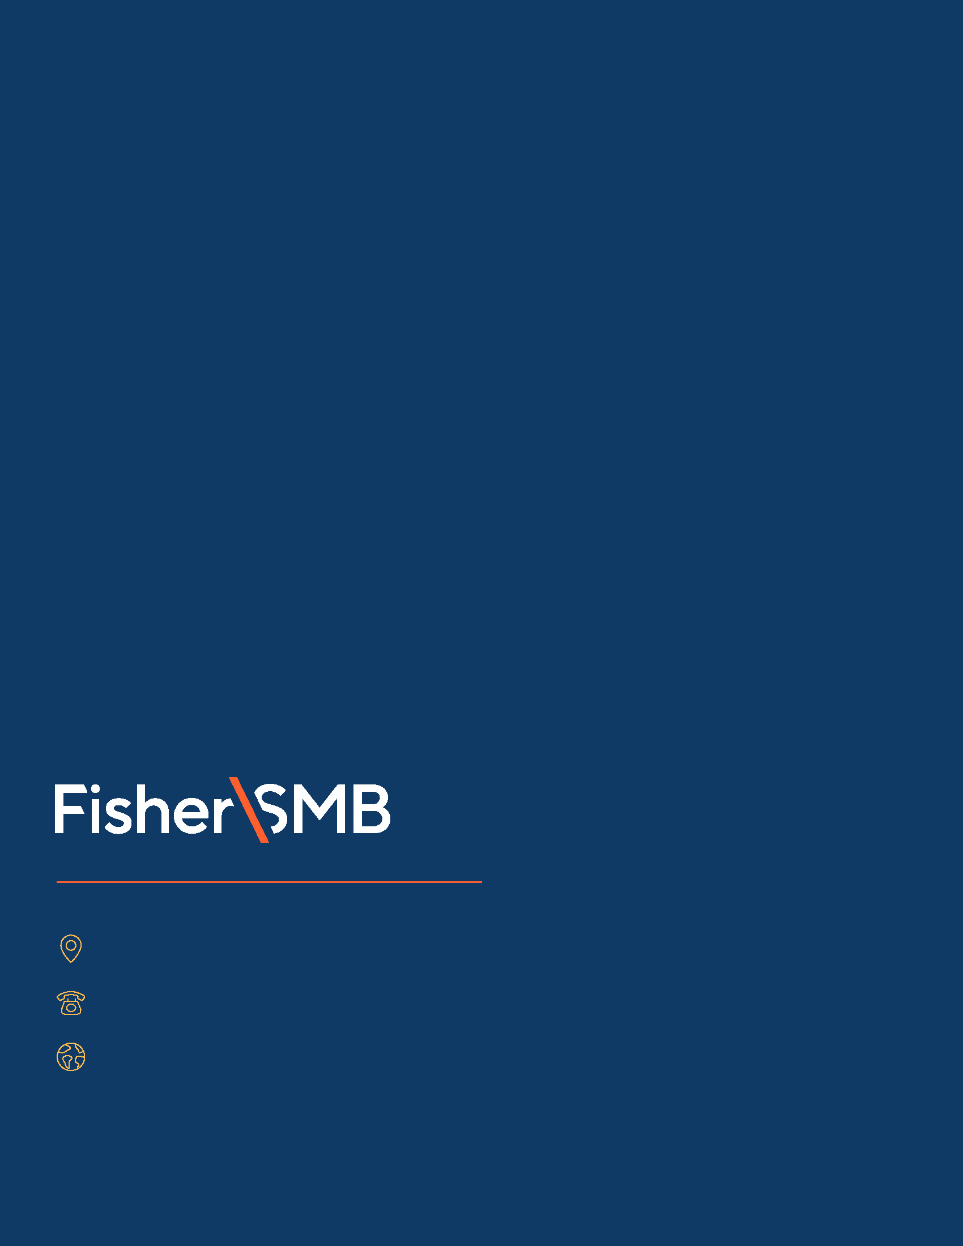

Investing in securities involves the risk of loss. Intended for use by employers considering or sponsoring retirement plans; not for personal use by plan participants. Fisher Retirement Solutions®, Fisher\SMBTM, FisherSMBTM, and all related logos and designs are trademarks of Fisher Retirement Solutions, LLC, which is not connected to Fisher Investments.

©2025 Fisher Retirement Solutions. All rights reserved. K012506MC June 2025

6404 International Pkwy, Ste 1100, Plano, Texas 75093

844-238-1247

www.fishersmb.com