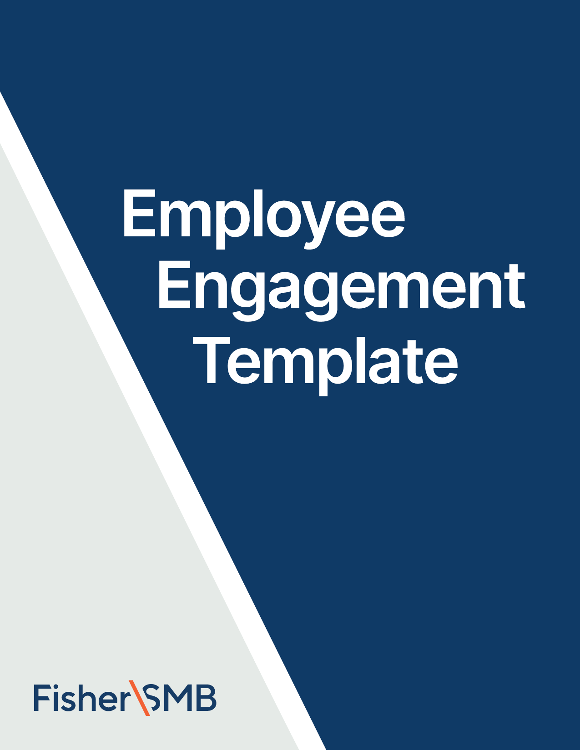



Email Template for December

Theme: Provide Planning Tools

Fill in the [highlighted parts]

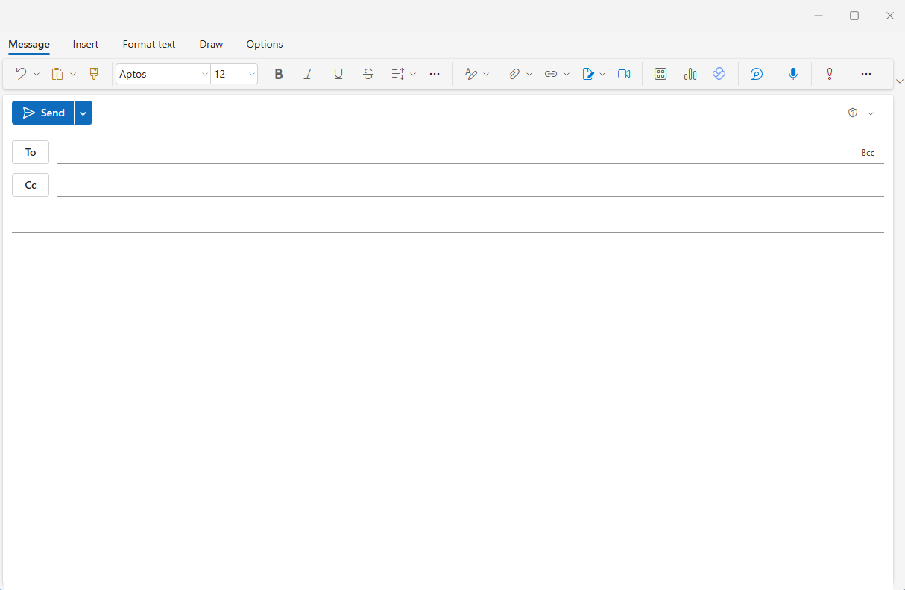

[Employees]

**Subject:** Take charge of your retirement with this budgeting tool

Hi [Name],

We get it – creating a budget can feel overwhelming or maybe even restrictive. But the truth is, a budget isn’t about limiting what you can do; it’s about empowering you to take control of your finances and achieve what matters most.

To make it easier, we have a Budget Worksheet resource to help you track your spending and savings in a way that works for YOU.

This worksheet will help you:

* Better understand your spending habits
* Adjust your spending if needed to create room for what truly matters
* Set meaningful financial and retirement planning goals that fit your lifestyle

Whether you’re new to budgeting or just need a fresh start, this tool is a great way to get started. [**Click here to take the first step today.**](https://www.fishersmb.com/budgeting_december/)

Remember, budgeting isn’t about perfection – it’s about progress. We’re here to support you every step of the way.

All the best,

[Your Name]

[Signature/Contact]

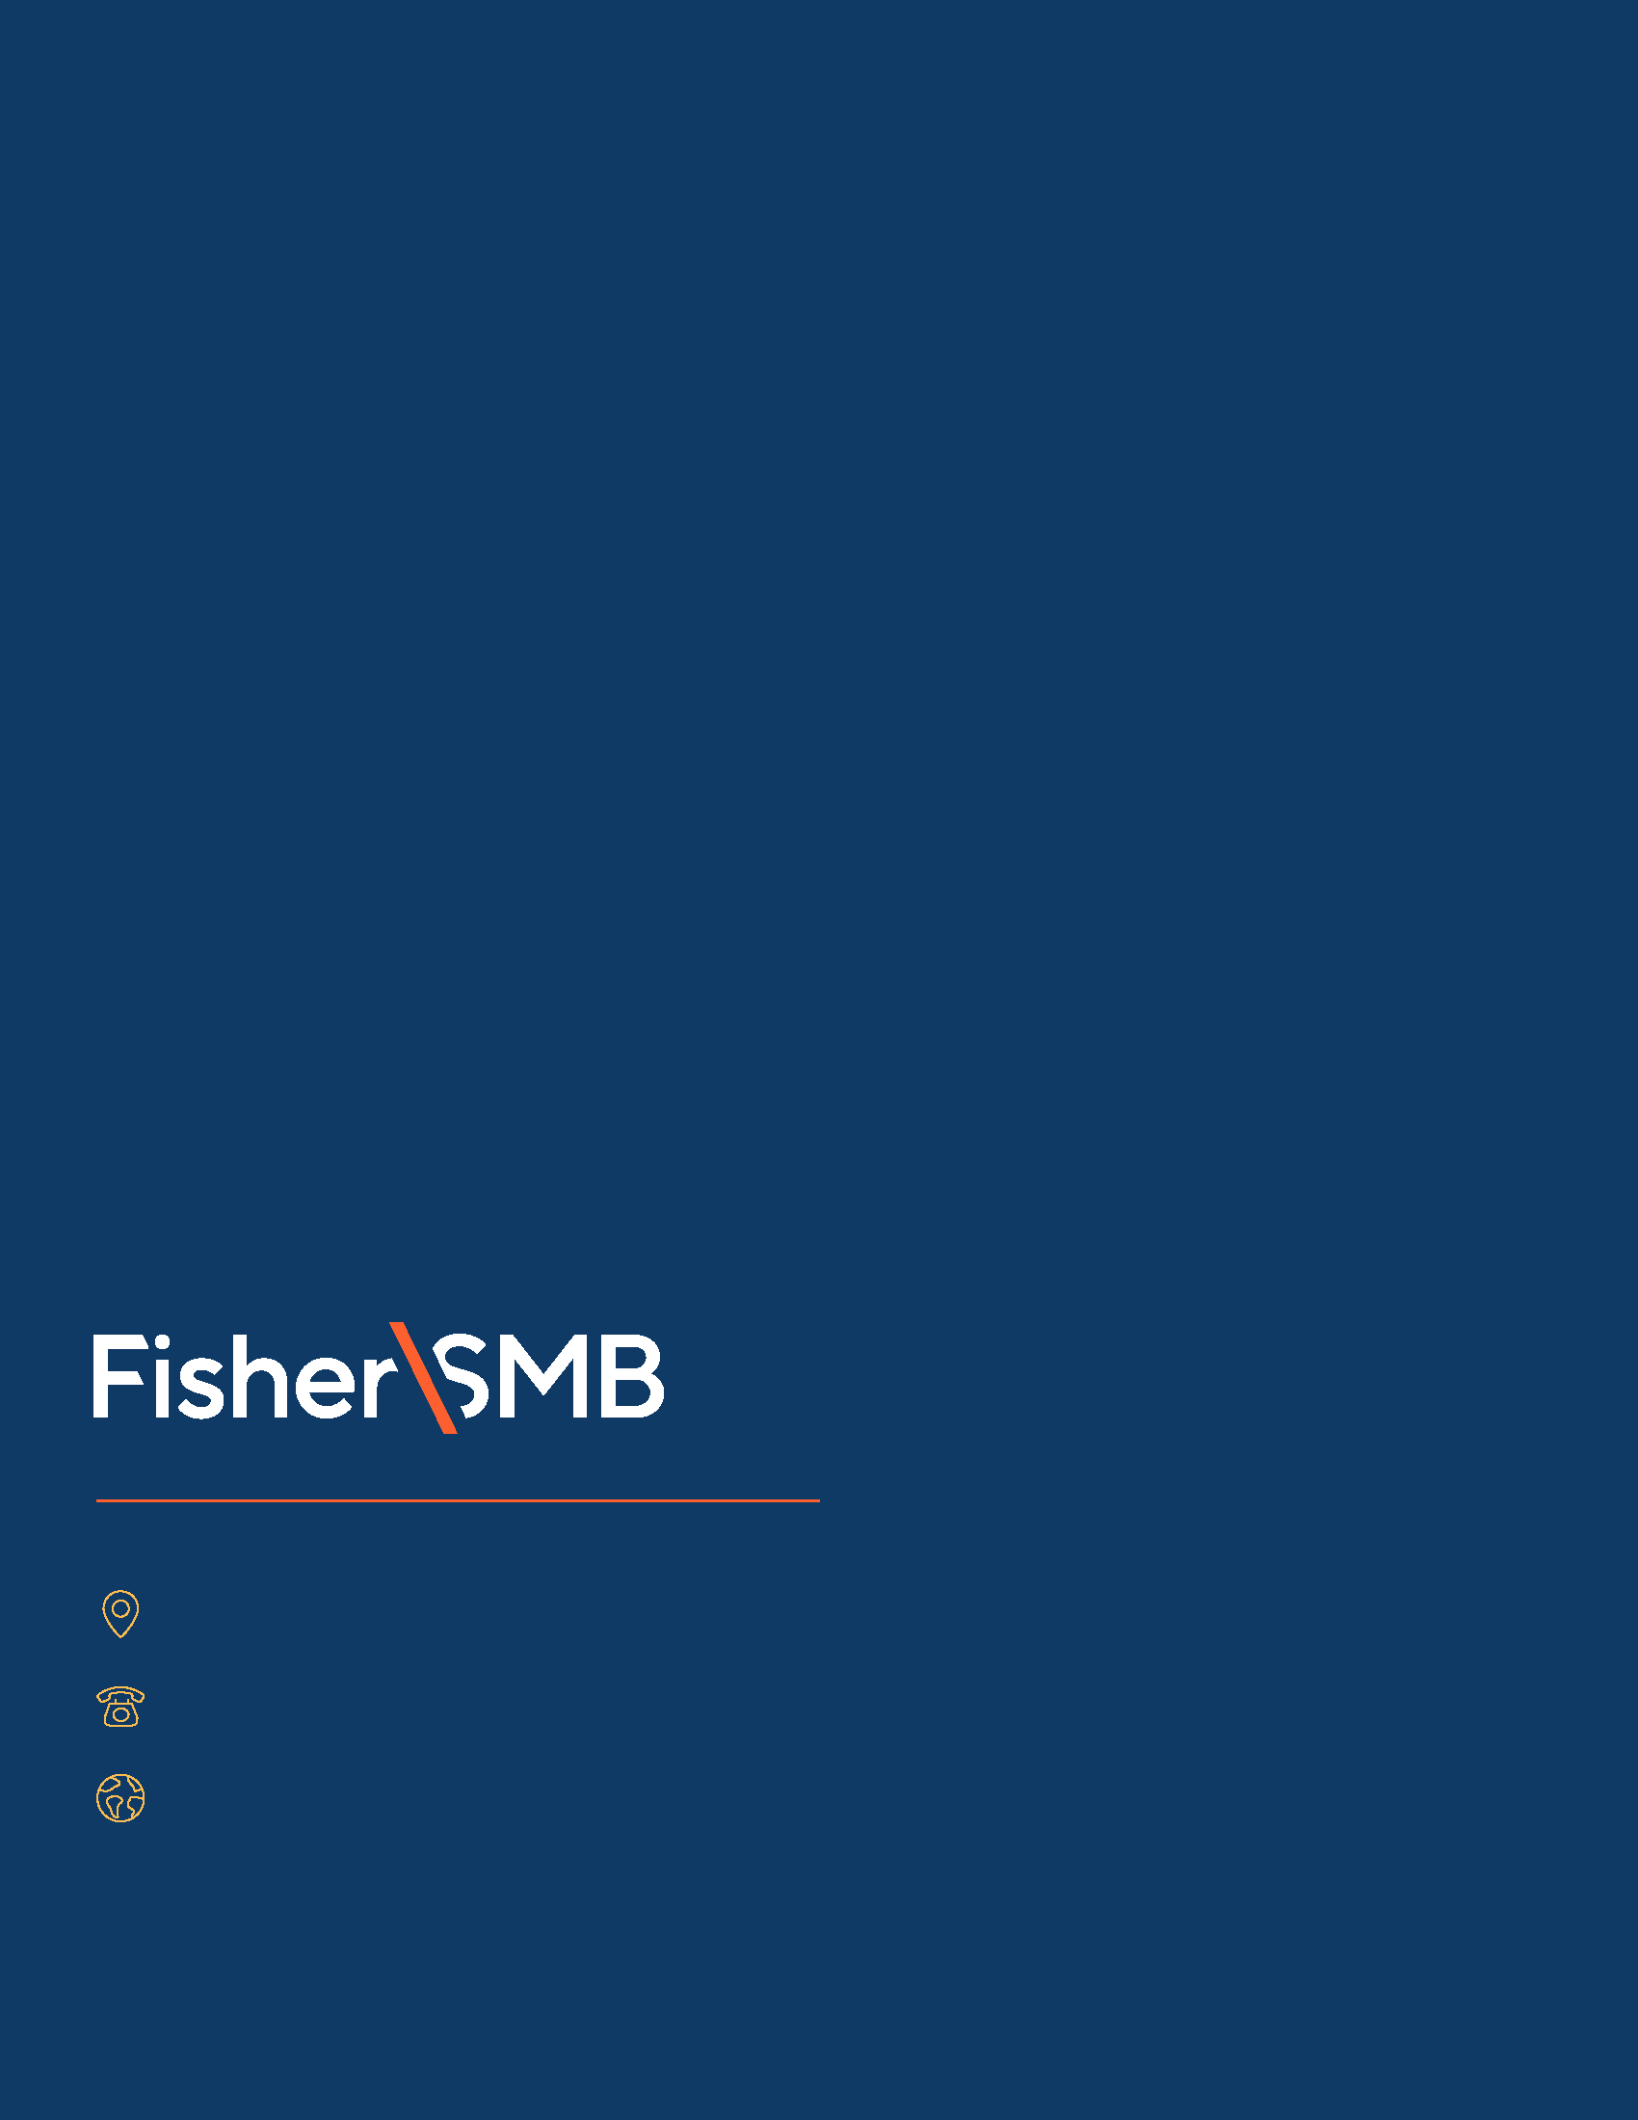

Investing in securities involves the risk of loss. Intended for use by employers considering or sponsoring retirement plans; not for personal use by plan participants. Fisher Retirement Solutions®, Fisher\SMBTM, FisherSMBTM, and all related logos and designs are trademarks of Fisher Retirement Solutions, LLC, which is not connected to Fisher Investments.

©2025 Fisher Retirement Solutions. All rights reserved. K012506MC June 2025

6404 International Pkwy, Ste 1100, Plano, Texas 75093

844-238-1247

www.fishersmb.com