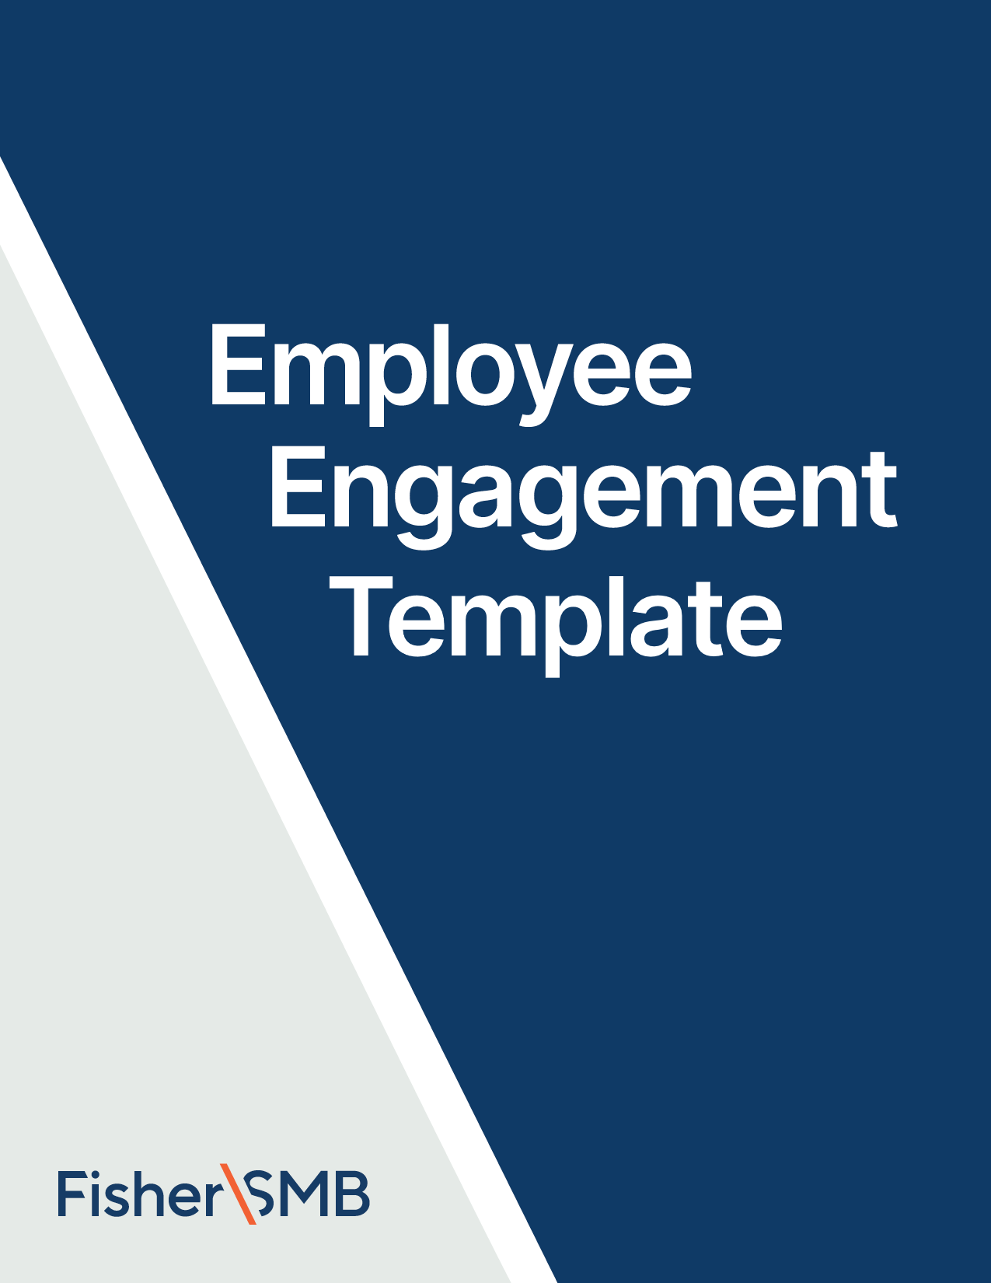



Email Template for April

Theme: Financial Literacy Month

Fill in the [highlighted parts]

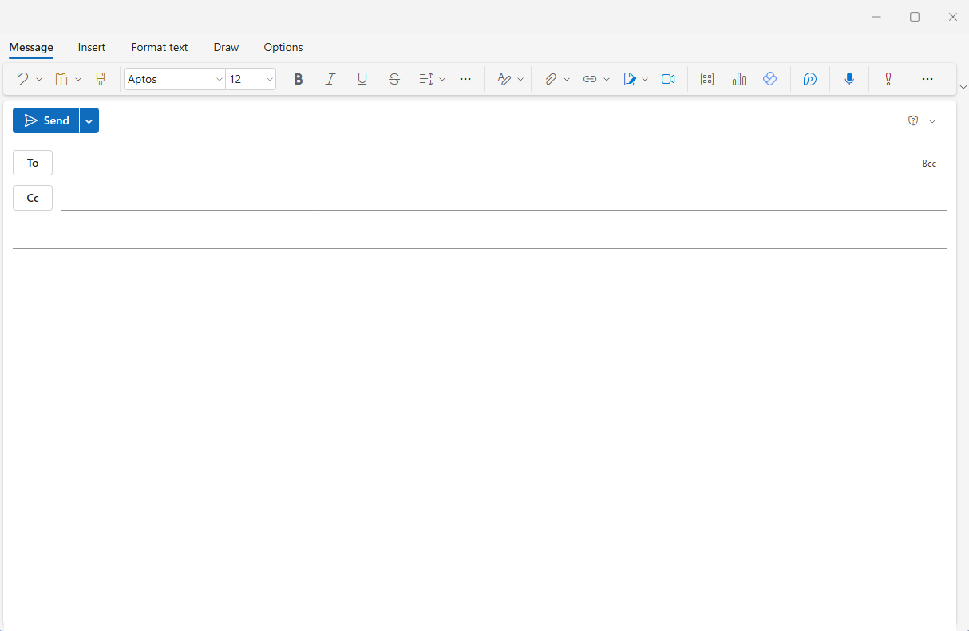

[Employees]

**Subject:** Financial Literacy Month: 401(k) words to know

Hi [Name],

There’s a lot of retirement planning jargon out there, and while you don’t need to know all of it, understanding a few important terms can be helpful. That’s why for Financial Literacy Month we’re offering this short vocabulary lesson.

* **Asset Allocation:** Within your 401(k), you can invest in a lot of different types of companies (stocks) and governments (bonds). You can also hold cash in your account. Deciding what investments go into a diverse portfolio is called your “asset allocation.”
* **Deferral Rate:** It’s recommended that you contribute some amount of your paycheck to your retirement plan. The percentage you choose is your deferral rate.
* **Vesting:** Some employer contributions to a retirement plan aren’t available to employees right away. Employers can put a vesting date on a contribution, which means that on that date the funds fully belong to the employee, but if an employee leaves before the vesting date, the company keeps the contribution.

**Learn More**

This Financial Literacy Month, take a few more minutes to learn how to manage your money so that you can enjoy it now and for the rest of your life. [**Watch this video**](https://fishersmb.com/lp/6-key-retirement-terms-ee/) about retirement savings strategies for each stage in life.

All the best,

[Your Name]

[Signature/Contact]

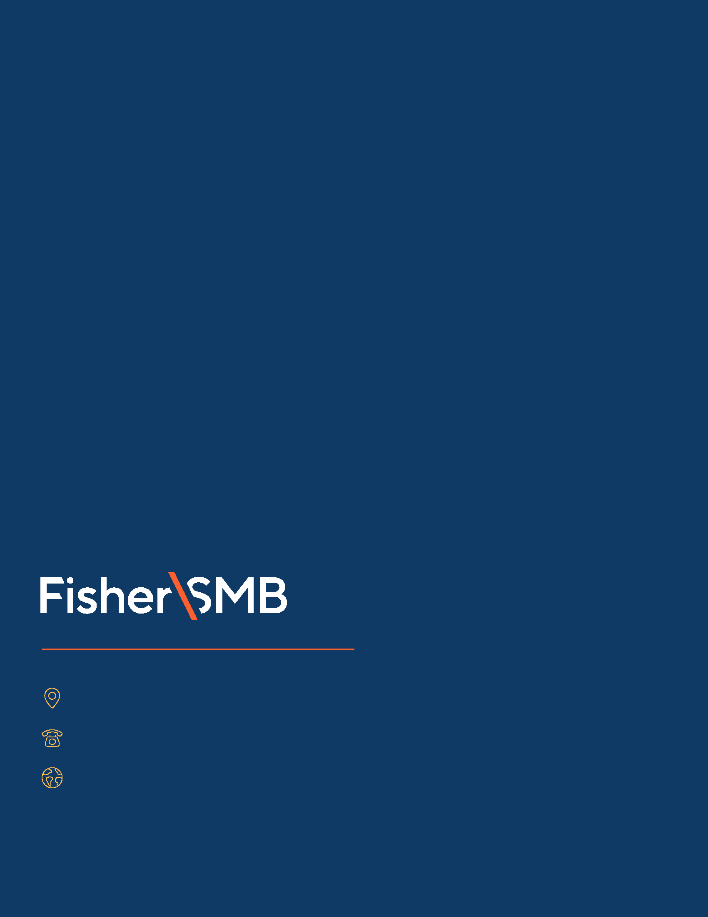

Investing in securities involves the risk of loss. Intended for use by employers considering or sponsoring retirement plans; not for personal use by plan participants. Fisher Retirement Solutions®, Fisher\SMBTM, FisherSMBTM, and all related logos and designs are trademarks of Fisher Retirement Solutions, LLC, which is not connected to Fisher Investments.

©2025 Fisher Retirement Solutions. All rights reserved. K012506MC June 2025

6404 International Pkwy, Ste 1100, Plano, Texas 75093

844-238-1247

www.fishersmb.com